# Paratext 9.1 Video Summaries

## PT9.1.01 Navigation

Floating windows allow a user to have projects, resources or tools open in separate windows and even move them to separate monitors.

In Paratext 9.1 the navigation features have been added to floating windows, so you can navigate to other passages. Also,

* Floating windows
* Quick Reference windows
* Assignments and Progress tool.
* any of the tools which allow you to set a filter for the current book.

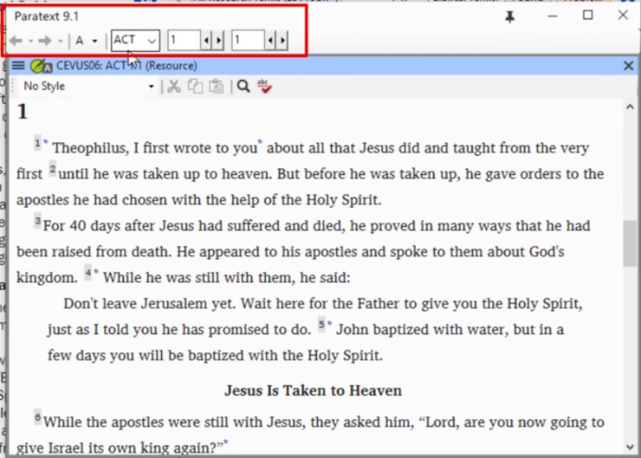

## PT9.1.02 SettingPriorities

A new feature in Paratext 9.1 is the ability to define and use priority groups. Priority groups are a way to let Paratext know the order in which books or chapters should be worked on.

### Using Pre-Selected Set

* Open the **Project** menu
* Choose **Project settings** then **Define priorities**
* Click Select Priority Definition 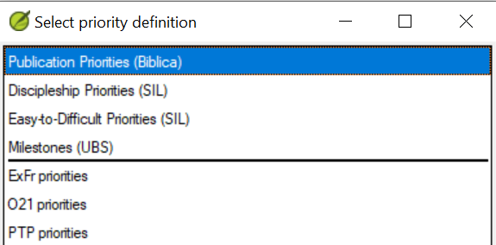
* Select this **SIL Easy to Difficult** set, a pre-selected set of books is presented.

### Setting Up Priorities

* Open the **Project** menu, choose **Project settings** and go to **Define priorities**
* Select the desired books, then click Right arrow button
* Click the three dots, choose **Edit**

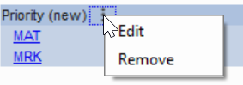

* Rename the group (e.g. Gospels).
* Rearrange the books as needed by clicking on a book and moving it up or down using the arrows buttons.
* To set specific chapters,
* Select a book name link
* Choose which chapters

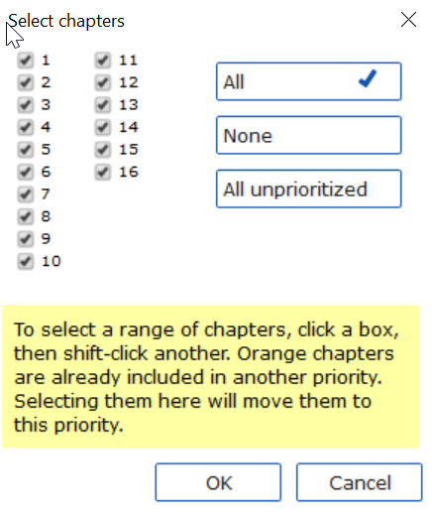

* Click **OK**

If you add a book which already has chapters defined it will only add the remaining chapters.

Change order of priorities using the up arrow.

### Using The Priorities

Once you've created priorities they can be used anywhere you would normally choose books. For instance,

* Find dialog (Ctrl+F)
* Click on **Choose**
* Select the **Priority** tab.

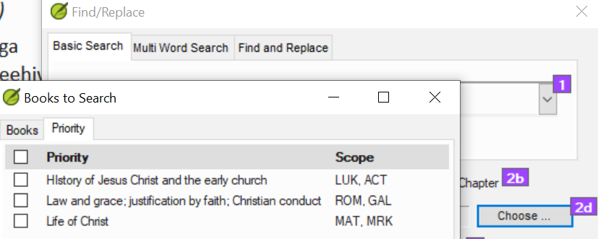

* Assignments and Progress (blue button), book selection can be set to a priority.

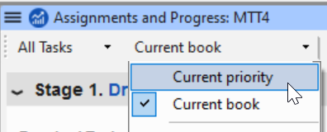

* (Project menu) Export PDF, click Choose

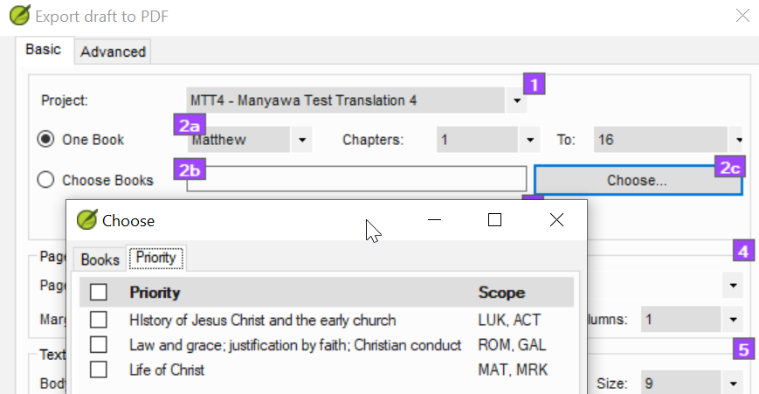

* Any window with a filter

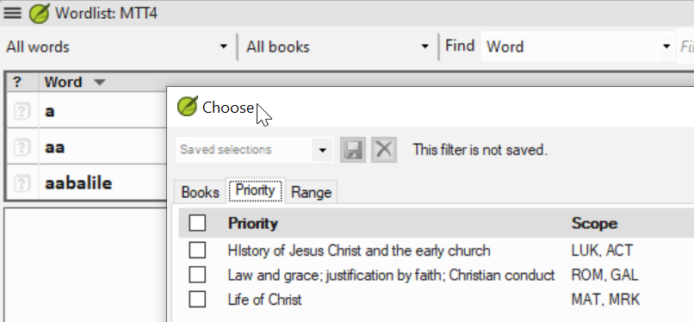

You can also define or redefine my priorities if you need to.

## PT9.1-03 My tasks view under assignments and progress

The assignments and progress window opens by default to the last view you had open.

The colors indicate:

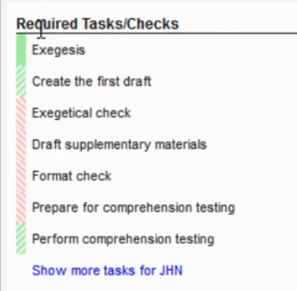

* Dark green or **solid green** that this is a task that you can work on.
* The **slashed green** indicates that it's a task that is waiting on you to do something.
* A **partial slash green** bar indicating that some of the task can actually be accomplished now. But some of it is still waiting.
* The **red slash** indicates that it's a task that is waiting on either someone else or another stage (as indicated in the status column).
* If there are more than 7 tasks, click the Show more tasks link.
* Notice that some of these are assigned to directly and some of them are assigned to the team.

### Set of books (priority)

There are generally three tasks or checks for a particular book.

If there are more tasks, click on the Show more tasks link will show a maximum of seven.

Click on Previous book or Next book to see those tasks.

### Filter for administrators

There's an additional filter here that allows you select a specific member of the team.

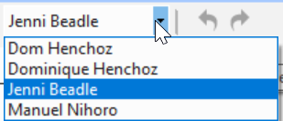

This allows you to see what things might be holding them up, what things may need waiting on, what things they may need assistance with to move the project forward.

## PT9.1-04 Optional checks in Assignments and Progress

In Paratext 9.1. there's a new option in the All Tasks view of Assignments and Progress to display optional checks that have been setup by an Administrator in the project plan.

* **Required checks** need to be completed in the stage unless you **postpone** them.
* **Optional checks** that have been added to the stage allow you to see that there are some issues that need attention.

You can correct these issues now but you are not obligated to correct the checks at this point.

They show up in each of the stages where optional checks have been added to the project plan.

**Setting up the optional checks Administrator**

* Click on the project menu icon and expand the menu
* Under **Project settings**, choose **Project plan**
* Click on the **Checks** tab
* Two columns are displayed: Required stage and Optional stage.
* 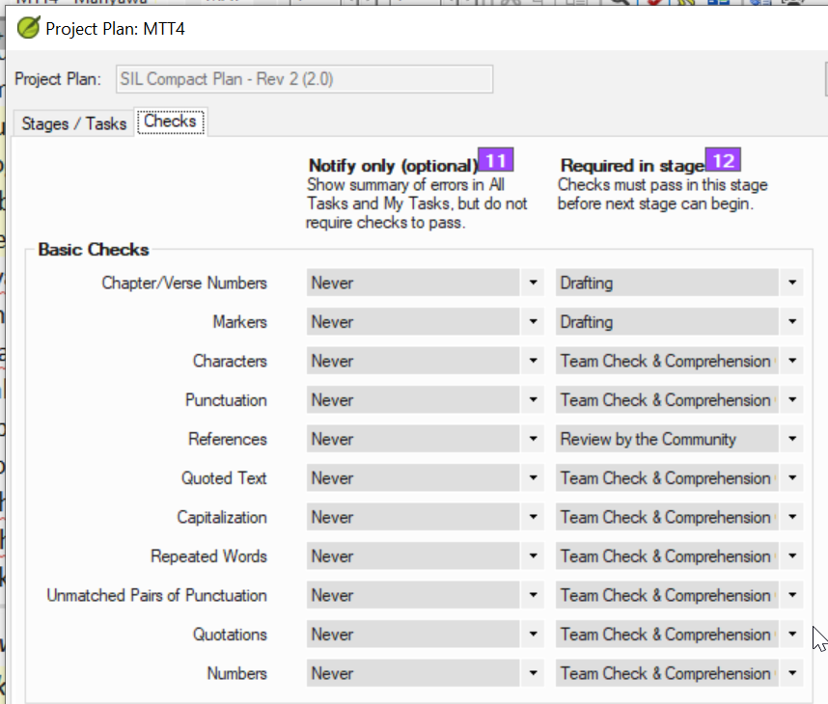
* Set the **Required in stage**
* Set the **Notify only (optional)** to an earlier stage if any.
* Click **OK**

**Using the Optional checks**

* Open Assignments and progress window
* Click the **Optional tasks/checks** link.
* Correct as many issues as you want. You can continue in the next stage.

## PT9.1.05 Using the Tasks Table in Assignments and Progress

The Tasks Table is a great place to make bulk assignments. Here, it is possible to assign a task across all the selected books or to assign an entire stage or book to a single person.

**Assign tasks across books in the Tasks Table**

* Click the Blue Assignments and Progress button
* Choose **Tasks Table**
* Use the verses filter to select books

**Assign a task to selected books to the same person**

* Below the task, click **Assign tasks**

Incomplete chapters can be reassigned but not completed chapters.

* A warning message will appear with options to overwrite all assignments or only those chapters that have not yet been assigned.

**Assign an entire stage to one person**

* Click the Assign stage button (at the top of each stage).
* Change assignments for certain tasks as needed.

Once you have completed the bulk assignment process you can fine-tune the assignments in the All Task view.

## PT9.1.06 Bulk Progress in Assignments and Progress

Another feature of Paratext 9.1 is the ability to handle bulk progress.

* Click the Blue Assignments and Progress button
* Choose **Stages Table**
* Click the tab menu and choose **Bulk Progress Mode**.

Checks are temporarily turned off.

* Click **All stages** button
* All of the stages are approved.

When you finish doing all your approvals you can go back and uncheck bulk progress mode.

Using the bulk progress mode allows you to quickly approve stages and move those checks to a later stage.

## PT9.1.07 Assigning and Copying Tasks

One of the most important new features in Paratext 9.1 is the ability to make bulk assignments of tasks.

* Open the **All task** view (of Assignments and progress)
* Click **Assign Stage**
* Choose a person.
* Change any individual tasks to somebody else.

**Copy assignments to other books**

* Click on the tab menu and then **Copy assignments**.
* Choose the book with the assignments (e.g. Mat)

Paratext will note if some assignments are assigned to multiple team members.

* Click **Choose books**
* Click **Assign**
* Paratext will warn if some tasks are already assigned.
* Choose either **Yes** or **No** to overwrite existing assignments.
* Check the assignments. Especially where specific chapters have been assigned.

## PT9.1.09 Updating a Project with a new version of the Base Plan

Project plans can be modified as needed. But occasionally the base plan upon which that project plan has been built will be modified. What happens if the base plan has been updated?

There are two ways to update the base plan.

**Method 1**

* Click on **Project** **menu**
* Choose **Project Settings** then **Project plan**.
* A warning is displayed that there is a new version of the plan and you can migrate.
* Click the link **Migrate to a new version of the project plan**.

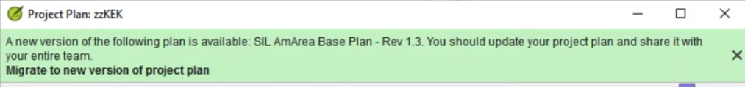

Choose either:

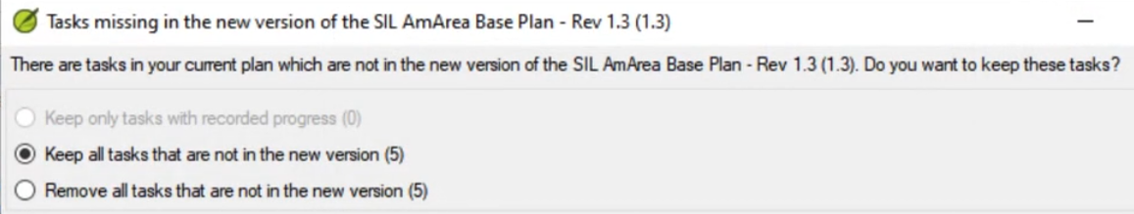

* Keep the tasks that are not in the new version,
* Remove all the tasks that are not in the new version,
* Keep tasks that had progress.
* Click **OK**

Paratext warns that you must do a send/receive, click **OK** to clear the message

*The plan has been updated.*

* A green message bar at the top gives you three options:
* Close the message
* View progress in the previous plan,
* Undo the base Plan update.

Note the version number has been updated.

* Click **OK**.

**Method 2**

* Click on assignments and progress.

If the base plan has been updated, then a message will appear showing that you can update.

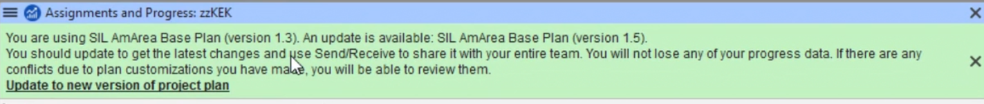

* Click on **Update to new version of project plan**.
* Choose to keep or remove the tasks.
* When you update it will do a send receive.
* Choose an option to view progress

So if a base plan has been updated then the administrator can update the project plan based on that updated base plan.

## PT9.1.10 How to share a layout

We want to create a layout that we can share with the members of the team.

### Save the current layout

* Open the desired projects and resources.
* Click the **Paratext menu** icon, under Layout choose **Save current layout**.
* Type a name (e.g. PDT15 with resources and tools).
* Click **OK**

### Share that with the team.

* Click **Project menu** then **Project settings** then **Share saved layouts**
* Choose the particular layout to send.
* Click **OK**
* Do a **Send/receive**.

### On a team member’s computer

* Do a **Send/receive**
* Click **Paratext menu**
* Under Layouts, choose **Shared layouts**
* Choose the layout from the list

If they are missing some resources Paratext will offer to download those resources.

* Click **Yes**, then **OK** to download